**The three domains of life and viruses and transcriptionally active in a high-salt desert microbiome**

Running title (<50 characters):

**Metatranscriptome of a high-salt desert microbiome**

**Gherman Uritskiy1, Michael Tisza1,2, Diego Gelsinger1, Adam Munn1, *James Taylor1,3, and *Jocelyne DiRuggiero1**

1. Cell, Molecular, Developmental Biology, and Biophysics, Johns Hopkins University, Baltimore MD 21218
2. National Institute of Health, Bethesda MD 20892
3. Department of Computer Science, Johns Hopkins University, Baltimore MD 21218

* Corresponding authors: [james@jamestaylor.org](mailto:james@jamestaylor.org) and [jdiruggiero@jhu.edu](mailto:jdiruggiero@jhu.edu)

**Originality-Significance Statement**

While the metagenomics of high-salt environments have already led to many vital discoveries, the transcriptional adaptations and functions of halophiles in natural environments remains understudied. We perform the first robust meta-omic investigation of a hypersaline desert ecosystem, linking the genomic and transcriptional elements of the community. Our analysis unexpectedly revealed that Eukaryotes may be the main drivers of carbon turnover in this extreme environment, despite halophilic Archaea and Bacteria dominating the biomass.

**Summary (<200 words)**

Microbial communities play a dominant role in the biosphere and, as such, understanding the mechanisms underlying their functional adaptations to environmental conditions is critical for predicting their behavior. Compared to metagenomic approaches, which offer a limited view of a microbiome’s capabilities, metatranscriptomic analyses allow for interrogation of real-time adaptations of a microbial community. This aspect of microbiome functioning has not been well characterized in natural high-salt environments. To address this knowledge gap, and to build a general framework of relating the genomic and transcriptomic components of endolithic microbiomes, we performed a robust meta-omic survey of extremophile communities inhabiting halite (salt) nodules in the Atacama Desert. We found that the major phyla of this halophilic community have strikingly different levels of total transcriptional activity, and upregulate different metabolic pathways in their transcriptomes. Most surprisingly, we report that a novel *Dolichomastix* alga – the only Eukaryote found in this system – was by far the most active community member, producing the vast majority of the community’s photosynthetic transcripts despite being outnumbered by members of the *Cyanobacteria* phylum. The divergence in the transcriptional landscapes of these segregated communities compared to the relatively robust metagenomic functional potential also suggests that microbiomes in each nodule undergo unique transcriptional adjustments to adapt to the local conditions. Finally, we report and characterize several previously unknown halophilic viruses, many of which exhibit transcriptional activity indicative of host infection. Taken together, our characterization and comparison of the metagenomic and metatranscriptomic elements of halite microbial communities allowed for inference of novel insights into the functioning of halophilic microbiomes.

**INTRODUCTION**

While transcriptional and metabolic activities of human-associated microbiomes are being actively explored, relatively little is known about these aspects of microbial community functioning in environmental microbiomes, particularly in high-salt environments {Ramos-Barbero, 2018 #8952}. To date, the study of hypersaline environments greatly advances the our understanding of core microbiology principles, evolution, and the origin of life itself {Paul, 2017 #9126;Oren, 2008 #6750;Gunde-Cimerman, 2018 #9128}. With advancements of sequencing technologies and bioinformatic methods, the metagenomic components of some high-salt natural microbiomes have been partially de-convoluted {Uritskiy, 2019 #9093} however the transcriptional and metabolic activities of such communities remain understudied {Ramos-Barbero, 2018 #8952}. Characterization of the metatranscriptomic activities of a hyper-saline microbial community would put into perspective the relationship between the transcriptional functioning of such communities and their perceived functional potential based on conventionally used amplicon and shotgun metagenomic approaches.

Metatranscriptomics present a much more accurate view of the community functioning, however such studies are difficult to conduct in most extreme environmental microbiomes due to low available biomass and extremely high sample complexity {Ramos-Barbero, 2018 #8952}. In a previous study of atmospheric microbiomes, comparative multi-omics showed that different taxa can contribute to varying degrees to the metagenomic and metatranscriptomic components of the microbiome {Amato, 2019 #9087}. A study of microbiomes found in hot springs surprisingly revealed that both aerobic and anaerobic organisms were simultaneously active in the spring, and contributing to the microbiome’s sulfur and nitrogen cycles {Tripathy, 2016 #9088}. In an alkaline lake, metatranscriptomic analysis of the communities inhabiting varying depths allowed the researchers to identify key pathways contributing to sulfur and arsenic cycling, and the organisms contributing to each process at varying depths {Edwardson, 2017 #9089}.

Investigating the relationships between the metatranscriptional and metagenomic components of partially segregated communities can also offer unique insight into the deterministic and stochastic factors contributing to community function. Recent metagenomic studies in a variety of isolated microbial communities {Louca, 2016 #8590;Uritskiy, 2019 #9090} revealed that they converge to very similar functional potential landscapes when subject to similar external conditions despite differing in terms of taxonomic composition, however it remains to be seen how this variance in the metagenomic components translates into the the transcriptional elements of these communities. In hydrothermal vents a multi-omic study revealed that microbial populations in distinct microbiomes diverge at the transcriptional as well as functional potential levels {Fortunato, 2018 #9080}. In human-associated microbiomes it has been shown that the metatranscriptional profiles further diverge from, and are weakly correlated with the functional potentials {Abu-Ali, 2018 #9121}, however such studies have not been done in environmental systems. One hypothesis is that their metatranscriptomes converge on a similar activity landscape just like their functional potentials. On the other hand, it is also possible that rapid adaptations to unique and transient changes in each isolated community force their metatranscriptomes to diverge at a given point in time.

To investigate the relationship between the functional potentials and functional activities of extreme microbiomes, we interrogated the metagenomic and metatranscriptomic components of halophilic endolithic (inside-rock) microbiomes found in the Atacama Desert, Chile. Despite an average annual precipitation of less than 1mm {Davila, 2015 #7953} microbes have evolved to survive here by living inside halite nodules (porous salt rocks), where they rely on atmospheric moisture absorbed by the salt through deliquescence {Robinson, 2015 #6954;Crits-Christoph, 2016 #8776}. Encased in rocks, halite communities have minimal exchange of biomass and nutrients with the outside, making them an interesting ecology model for studying general microbial community assembly principles and the effects of climate change on microbiomes {Uritskiy, 2019 #9090}.

Halite microbiomes rely on carbon fixation by a single species of halophilic alga and 1-3 species of cyanobacteria (*Halothece* and *Euhalothece*), which support a number of heterotrophs, including *Halobacteria* and *Bacteroidetes*, which constitute the majority of the system’s biomass {Crits-Christoph, 2016 #8776;Robinson, 2015 #6954}. The community was also found to contain a diverse consortia of viruses infecting most members of the Archaea and Bacteria domains {Crits-Christoph, 2016 #8776}. Analysis of temporal {Uritskiy, 2019 #9090} and spatial {Finstad, 2017 #8580} dynamics of this community revealed water to be the governing factor its taxonomic composition. With this in mind, the humidity and temperature swings in the Atacama Desert throughout the diurnal (day/night) cycle likely have an impact on microbiome functioning. Characterization of the small non-coding RNAs in the community also revealed that sRNAs are used in the community to down-regulate mRNA targets, suggesting that these communities are capable of dynamic transcriptional adaptations to environmental conditions {Gelsinger, 2019 #9125}. In this study, we interrogated the metatranscriptomes of several halite nodules from different time-points, placing our observations in the context of their metagenomic composition and revealing the key transcriptional activities in this unique microbial community.

**RESULTS**

**Community taxa varied in their contribution to the metatranscriptome**

The endolithic halite microbial communities have been well described in terms of their taxonomic distribution {Crits-Christoph, 2016 #8776}. Here, we contrast the taxonomic composition of the halite metagenome with that of the metatranscriptome. 12 biological halite replicates were collected and their genomic DNA and total RNA sequenced, yielding a total of 96.0M and 81.2M, respectively. The RNA reads were then in-silico riboreduced to remove rRNA reads, yielding a total of 12.8M non-ribosomal reads. The overall taxonomic composition was determined by aligning RNA reads to the taxonomically-annotated metagenomic assembly (Fig. 1). This comparison highlighted core differences between the community taxa abundance (fraction of DNA reads) and overall gene expression levels (fraction of RNA reads), as the transcription of several taxa are over- or under-represented with regard to their prevalence in the community. The total transcriptional activity of Eukaryotes in the community was much higher than their genomic abundance. Indeed, 12% of non-rRNA metatranscriptomic reads were mapped to Eukaryotic contigs, compared to only 1% in metagenomic reads. It was found that the diversity in predicted taxonomy of the Eukaryotic component was attributed to the lack of similar sequences in the taxonomic database, rather than true taxonomic variety. Indeed, nearly all Eukaryotic contigs were found to belong to a single metagenome-assembled genome (see following sections). In contrast, bacteria – particularly *Bacteroidetes* – represented a smaller fraction of the metatranscriptome compared to the metagenome (8% vs 15%).



*Fig. 1: Taxonomic composition of the halite community as estimated from the metagenome (A) and metatranscriptome (B). The relative compositions were estimated from the read coverage of contigs belonging to the respective taxa.*

We found significant differences between the abundances of individual contigs and their respective total transcriptional activity levels. The relative abundance of contigs, expressed in copies per million (CPM), was estimated from their DNA read coverage and the contig transcriptional activity was estimated from the average expression of genes carried on the respective contigs, expressed in transcripts-per-million (TPM). Contigs from different taxa displayed drastically different transcriptional activity levels, which were not necessarily correlated with their abundance levels (Fig. 2A). In particular, the three phototrophic species – *Halothece* and *Euhalothece* cyanobacteria and a *Dolichomastix* green alga – displayed similar average gene transcriptional levels despite being present at notably different genomic abundances. As previously observed in the overall taxonomic composition of the community, the algae contigs (shown in black) displayed extremely high levels of transcriptional activity (y-axis), despite being present at very low genomic abundance (x-axis). On the other extreme, *Nanohaloarchaea* (shown in blue) had very low gene transcription levels. The differences in abundance and transcriptional activity levels of other taxa were not as extreme, however significant variation in transcriptional activity was observed within the highly diverse groups of *Bacteroidetes* and *Halobacteria* (the dominant class within the *Euryarchaeota* phylum).

Further quantifying the relationship between relative abundance and transcription levels in each taxon (Fig. 2B) or metagenome-assembled genome (42 MAGs, completion>70%, contamination<5%; Data 1; Fig. 2C) supported that the *Chlorophyta* (algae) was an order of magnitude more active than most other taxa in this community. In terms of the total number of transcripts contributed (circle diameter; Fig. 2B, 2C) algae contributed more to the metatranscriptome than both of the other phototrophs combined. When considering relative abundances of the chromosomal, mitochondrial and chloroplast DNA components of the algae separately (Fig. 2C), we sew that the organelle genomes were much more numerous relative to the main genome (approximately 10X for mitochondria and 20X for chloroplasts). This abundance difference only partially explained the high transcriptional activity of chloroplasts and mitochondria, as their transcription was found to be high even relative to their high abundance (x-axis of Fig. 2C). *Mamiellophyceae* green algae have been previously characterized to have a single mitochondria and chloroplast, so these coverage differences suggested there were multiple genome copies in each organelle. The chloroplast genome was 2.2 time more numerous that even the most abundant Cyanobacteria (*Halothece*), which in combination with the high relative transcriptional activity of the alga led to the chloroplasts and *Halothece* to contribute a near-equal total number of RNA transcripts. This result was unexpected considering the chloroplast genome was nearly two orders of magnitude smaller in size compared to the *Halothece* genome (95Kbp vs 3,577Kbp).

While some taxa were more transcriptionally active than others, the relative activity of individual contigs and MAGs also changed between replicates. Indeed, the transcriptional activity of MAGs (expressed as the ratio of total RNA expression to the total DNA abundance) changed significantly between samples (Fig. S1). This variance in activity was so great that an attempt to correlate the abundance and transcriptional levels of any given MAG across the replicates (Fig. S2C) showed that these metrics significantly correlated for only a small subset of organism (Fig. S2D). These findings were also verified at the assembly level to check for binning biases (Fig. S2A,B).



*Fig. 2: (A) The relative total transcriptional activity (y-axis) of contigs in relation to their abundance in the metagenome (x-axis). (B) The total contributions to the metatranscriptome (circle size) of the major taxa, shown in relation to the average abundance of each individual taxonomic component at the contig scale (y-axis) and its transcriptional activity to abundance ratio (x-axis). (C) A similar summary of total transcriptional activity, but shown for high-quality MAGs. The total transcriptional activity of a given contig or MAG was estimated to be the median read expression (TPM) of its genes. The total relative abundance was estimated from its average DNA read coverage.*

**Virus diversity and transcriptional activity**

To further investigate viral diversity and transcriptional differences across samples, we analyzed the viral components of the halite community using using protein sequence homology. We extracted 91 viral contigs ranging in size from 5Kbp to 50Kbp. The halite viruses expanded our knowledge of order Caudovirales (prokaryotic head-tail viruses including families Myoviridae, Siphoviridae, Podoviridae and so-called Haloviruses) and of the archaeal virus families Pleolipoviridae and Sphaerolipoviridae (Fig. S5). The extracted viral contigs represented expansions of some extant genera (as determined by VContact2; see methods) while a number of contigs established previously unidentified genus-level clades. CRISPR spacer similarity and nucleotide sequence similarity between viral genomes and host chromosomal regions were used to identify putative hosts of prokaryotic viruses, leading to the identification of the hosts for 44 viruses, and revealing that the viruses primarily targeted *Halobacteria* and *Salinibacter* hosts for infection. Neither the abundances of transcriptional activities of the virus and their host were significantly correlated across the replicates (FDR>10%). The most abundant and transcriptionally active viruses belonged to a new clade of *Myoviridae* viruses, predicted to infect members of the *Halobacteria* class (Fig. 3). Most highly expressed genes were annotated as being virion structural components or DNA replication/mobilization, indicating that active lytic infection was occurring in these communities at the time of sampling.

In order for a virus to be transcriptionally active it needs inside a host cell, which suggests that the activity level of a given virus in a sample is dependent not only on its abundance and transcription rates, but also on its infection success. Consistent with this, we found that a virus’s high genomic abundance does not necessarily lead to transcriptional activity, and most viruses had no detectable transcription in most samples (Fig. S3). In a given sample, many transcriptionally active viral contigs were not highly abundant, and highly-abundance contigs were not necessarily active at the transcriptional level. Indeed, computing the Pearson correlation of viral abundance to viral transcriptional activity revealed that only 12 out of the 91 virus contigs showed significant positive correlation (Fig. S4).

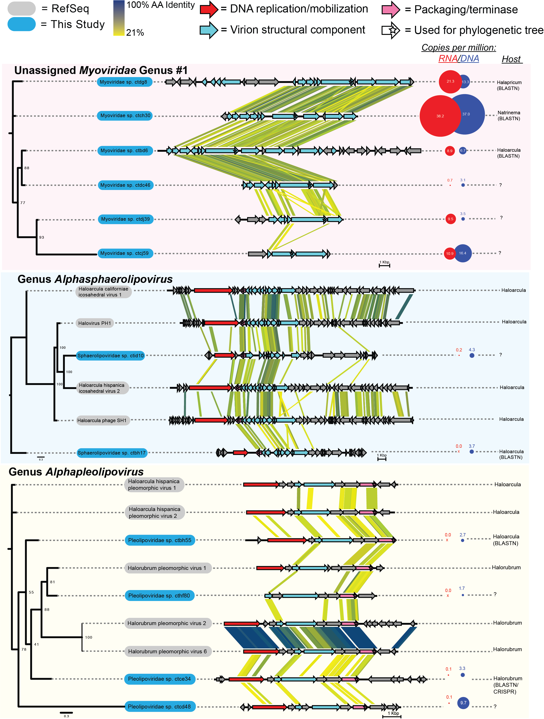

*Fig. 3: Characterization of viral contigs from the halite community (in blue) belonging to a novel Myoviridae genus cluster. Genome maps were drawn and compared with TBLASTX and EasyFig. Circles represent metagenomic abundance (copies per million reads) and metatranscriptomic activity (transcripts per million reads); putative host are shown on the right.*

**Characterization of putative genome of novel *Dolichomasti*x alga**

Through a combination of assembly and binning methods we reconstructed the alga chromosomal, chloroplast, and mitochondria draft genomes. The metatranscriptome was also assembled to obtain the complete sequence of the 18S rRNA sequence. This 18S rRNA sequence was found to be 99% identical to the sequence previously extracted from the halite microbiome using an amplicon-based approach {Robinson, 2015 #6954}, and 94% identical to a putative *Dolichomastix* alga found in lake Tyrell {Heidelberg, 2013 #9086}. Our re-evaluation of the phylogenetic placement of this sequence confirmed that this alga belongs to the *Dolichomastix* genus (Fig. S6).

Comparing the relative contributions of the phototrophs to the functioning of the community in terms of photosynthesis revealed that the halite alga contributes significantly to this pathway. We identified several key genes from the photosynthetic pathway that were annotated and present in all three phototrophs found in this community – the alga *Dolichomastix* and the Cyanobacteria *Halothece*, and *Euhalothece* (Fig. 4). For almost every single photosynthetic gene, the algae contributed an order of magnitude more transcripts than both of Cyanobacteria combined. These results suggest that not only were the algae disproportionately active given their low abundance in the samples, but also that they were the major contributors of photosynthetic transcripts. If the photosynthetic gene transcriptional levels were assumed to be proxies to photosynthetic activity, it would be inferred that algae are the major primary producers of this community.

Given the high importance of *Dolichomastix* alga for community carbon fixation, we further characterized its genome in relation to its closest fully sequenced phylogenetic relatives *Ostreococcus tauri* and *Micromonas pusilla* (marine algae), and another halophilic algae *Dunaliella salina*. The extracted halite chromosomal genome was 10.3Mbp long, compared to 13.1Mbp in *O. tauri*, 22.4Mbp in *M. pusilla*, and 343.7Mbp in *D. salina*. The chloroplast and mitochondrion genomes were 95Kbp and 46Kbp, but we were unable to compare these sizes due to unavailability of non-chromosomal sequences in closely-related algae. Using BUSCO {Seppey, 2019 #9109}, the genome was evaluated to be 45.3% complete with 0.2% contamination, however given the lack of highly compact Eukaryotic genomes in the BUSCO database we could not take these metrics at face-value when comparing the size of this MAG to the other algae. All four genomes were functionally annotated with the same method and the isoelectric point (p*I*) for each gene was estimated (Fig. S7A). The differences in predicted p*I* distributions of the genomes revealed potential differences in the intra-cellular environment. We found that the p*I* distribution of the *Dolichomastix* halite alga to have a prominent high-pH peak, which was notably different from the distribution previously reported based on a small number of identified genes {Crits-Christoph, 2016 #8776}. This distribution was starkly different from that of *D. salina*, but relatively similar to its non-halophilic closest phylogenetic relatives *M. pusilla* and *O. tauri*. However, the non-halophiles displayed a trimodal pI distribution curve, with a notable fraction of the genes predicted to encode for proteins with a pI of 10.5 or greater. *Dolichomastix* on the other hand, lacked this third peak, similar to a more distant but halophilic algae *D. salina*. The majority of *Dolichomastix* genes with a high predicted p*I* (p*I*>11) were histone and DNA-associated proteins, which need to be alkaline to maintain function.

To investigate whether the genes encoding for high pI proteins in *M. pusilla* and *O. tauri* were present in the *Dolichomastix spp.*, we aligned the amino acid sequences of the *M. pusilla* and *Dolichomastix spp.* genomes. Of the 105 *M. pusilla* genes encoding for high-p*I* proteins that were found to have homologues in *Dolichomastix spp.*, 80 encoded for proteins with a significantly lower p*I* in the *Dolichomastix* homologue (Fig. S7B). These acidified proteins were not significantly enriched for any specific pathway or cellular compartment, but many were chaperones, mRNA processing proteins, and DNA-binding proteins.

To further compare the halotolerant *D. salina* and *Dolichomastix* *spp.* genomes, we investigated homologs of important high-salt adaptations proteins. Previous proteomic studies of *D. salina* subjected to increasing salt concentrations identified 51 cellular and 46 membrane-bound proteins that were upregulated under high-salt stress {Liska, 2004 #9085;Katz, 2007 #9084}. These genes were aligned against the *Dolichomastix* genes to find 33 homologous genes that could play a role in the high-salt tolerance. Of these, all the genes were actively expressed in *Dolichomastix*, and a significant majority were highly expressed (>10TPM, Fig. S7C). In particular, we identified several highly expressed chaperones and heat-shock proteins, as well as a number of mitochondrial and chloroplast genes. This suggests that *Dunaliella* and *Dolichomastix* may share similarities in their adaptations to high salinity.



*Fig. 4: Expression of photosynthetic genes identified in the genomes of the 3 majors phototrophs in the halite community.*

**Major functional pathways highly expressed in the community**

Investigating the expression levels of functional pathways from the KEGG Brite database in the halite community allowed us to identified upregulated transcriptional activities in this community. The relative abundance of each gene in the DNA samples was estimated from the DNA coverage of the contig that it lies on, expressed in copies-per-million reads (CPM) and the relative expression level of the genes was expressed as transcripts-per-million reads (TPM). The total functional potential abundance (CPM) of each pathway was estimated by adding together the abundances of genes constituting each pathway. Similarly, the transcriptional activity (TPM) of pathways was estimated from the sum of expression values of corresponding genes. Only pathways that were predicted to be present in the metagenome (see methods) were considered, and standardizing to an equal sum of pathway TPM or CPM. Interestingly, clustering between RNA replicates did not reflect the sampling time-points or the taxonomic compositions of the samples (Fig. 5). Most highly-expressed pathways such as translation, and nucleotide metabolism were also present in high levels in the functional potential. Photosynthesis, however, was not only one of the highest expressed pathways in the community, but also had relatively low levels of abundance at the DNA level. Similarly, the opsin production pathway was expressed at relatively high levels when taking into consideration its low abundance in the functional potential. By comparing pathway abundance to their total expression, we are able to infer which pathways were transcriptionally prioritized by the community.

Furthermore, by standardizing to the maximum value (abundance or expression) in each pathway, we were able to visually compare the relative expression of each pathway in relation to its abundance in the metagenome (Fig. S8). The clustering of community metabolic pathways resulted in three groups – those that were expressed lower, higher, or equal to their respective abundances in the community’s functional potential. Among the lowly-active pathways, we found cellular membrane and cell wall components, including most lipid metabolism and synthesis pathways, and glycan biosynthesis. In contrast, in the highly expressed pathway group, we found functions essential to the functioning to this endolithic community such as the two major metabolic pathways for carbon fixation and utilization – photosynthesis and oxidative phosphorylation, respectively. The other group of highly expressed pathways dealt with protein synthesis and processing. In particular, multiple pathways for transcription and translation were very active, as were pathways for protein folding, trafficking, and degradation.



*Fig. 5: Relative abundance and expression of major KEGG functional pathways in the metagenomic (red) and metatranscriptomic (blue) samples, respectively. The pathway abundance (DNA) and expression (RNA) value were the combined total CPM or TPM (respectively) of the genes that constitute that pathway. All samples were standardized to an equal total coverage of pathways.*

**Pathway expression enrichment in major taxa**

We further explored the pathways most transcribed for each of the major taxonomic groups in the community, *Halobacteria, Bacteroidetes, Chlorophyta* (green algae), *Cyanobacteria*, *Proteobacteria, Actinobacteria, and Nanohaloarchaea,* by computing the ratio between the standardized pathway expression to pathway abundance (in the metatranscriptome and metagenome, respectively; Fig. S9). Importantly, these ratios did not represent a taxon’s overall functional landscape, but rather the degree to which a specific pathway is expressed.

While each major taxon in the community had a unique transcriptional profile, we found there to be many similarities between their highly expressed pathways. For all major taxa except for *Nanohaloarchaea*, protein folding, sorting, and degradation pathways were very among the most highly expressed pathways. General carbon metabolism and oxidative phosphorylation were also highly expressed, although the specific sugar metabolism pathways were highly varied. The community's least active members – the *Nanohaloarchaea* – where the most different from the other community phala. Their only highly-expressed pathways were for nucleotide metabolism, transcription and translation as well as pathways for metabolizing simple sugars such as such as fructose and pyruvate. Using manual BLAST alignments, we also identified fragments of the SPEARE gene in two of the MAGs (T17_Nanohaloarchaea_45_3 and T17_Nanohaloarchaea_46_6), however none of them were expressed in the metatranscriptome. Not surprisingly, the two phototroph groups in the community – *Chlorophyta* and *Cyanobacteria* – clustered together in their transcriptional activity, as they were the only groups to carry and express the photosynthesis pathway, which was highly active in both taxa. However, the other metabolic activities in the two phototrophs were quite distinct, with *Chlorophyta* strongly prioritizing glyoxylate metabolism, while *Cyanobacteria* prioritized fructose and pentose metabolism. The opsin production pathway, which was one of the most upregulated pathways in the metatranscriptome compared to the metagenome, was predominantly expressed in *Halobacteria*.

**No transcriptional differences detected between daytime and nighttime**

Samples for metatranscriptomic (and the corresponding metagenomic samples) were collected at 2 time points during the diurnal (day-night) cycle – 9 am and 9 pm – with 6 replicates each, to uncover temporal transcriptional adaptations of community members. The 9am time point was characterized by bright light (1h after sunrise) and high relative humidity (60%-80% RH), while the 9pm time point was collected in the dark (3 hours after sunset) and at low humidity (40%-50% RH). Differential expression analysis was done on the entire community, standardizing the gene expression to the abundance of its contig in the DNA or the total contig expression in the RNA (Fig. S10A). DESeq identified differentially expressed genes, however the false discovery rate was greater than 5%, and the over- and under-expressed genes belonged to a seemingly random set of pathways. This analysis was also repeated for individual high-quality MAGs (>70% completion, <5% contamination), including the *Cyanobacteria* and *Dolichomastix* MAGs (Fig. S10B,C). This analysis included a much more robust standardization scheme that accounts for the abundance (or total expression) of the entire organism, but did not yield any significant differentially expressed genes. We were also unable to detect significant differences in total pathway expression (Fig. 5).

**The functional profile was more variable than the functional potential**

To address the high inter-replicate metatranscriptome variation and to investigate how pathway abundance and pathway transcription differences contribute to this heterogeneity, we computed the variance of KEGG pathway abundance or expression values across replicates, standardized to range from 0 to 1. This transformation allowed for direct comparison of the variance in pathway abundance to the variance in pathway expression in the whole community or a taxon of interest. Comparing these normalized abundance and expression values across across all of the community pathways revealed that the pathway expression levels varies greater than pathway abundances (Fig. 6). In fact, this observation held up across all tested major taxa in the community (Fig. S11). This suggested that while the overall functional potential of these communities remained stable between replicates, which is consistent with previous findings, their transcriptional activity changed significantly in individual halite nodules.



*Fig. 6: KEGG pathway (A) CPM abundance and (B) TPM expression in sample replicates, standardized to the highest value in each column. Tracks below the heat maps show the CPM of TPM values from individual replicates, standardized to the average between all the replicates.*

**DISCUSSION:**

Our detailed interrogation of the metatranscriptomic and metagenomic components in a halite model ecosystem provided several new key insights into the functioning of halophilic and segregated endolithic microbial communities. One of the striking qualities of these halite endolithic communities is their high inter-replicate variance. Previous research showed high variation in inter-nodule taxonomic composition and functional potential {Uritskiy, 2019 #9090}, however we found the inter-nodule transcriptional differences to be much greater. These results resemble the conclusions of an individualized gut microbiome multi-omic screening, in which the functional potentials and metatranscriptional landscapes of gut communities were only loosely correlated {Abu-Ali, 2018 #9121}. These differences were detected both in the overall functional landscape of the community as well as in the transcriptional activities of individual genomes.

The varied transcriptional profiles of individual halites likely stem from a combination varying rock topology, humidity and temperature metrics, which we were not feasible to measure due to practical limitations and compounding factors in this study. Previously, water has been described as the major driving factor of the taxonomic diversity in this hyper-arid environment {Meslier, 2018 #8768;Finstad, 2017 #8580}. It is likely that water availability also affects the transcriptional adaptations of this community. In particular, it is likely that internal humidity can vary significantly from nodule to nodule depending on their capacity for water retention, which in turn could depend on structural characteristics such as size, degree of porousness, and shape {Davila, 2013 #6726}. However, the relative convergence of functional potential of the halite community pan-genome is primed to survive in a range of conditions. One explanation for this is that the differences in water availability are transient, as the halite nodules “recharge” after every high-humidity night through deliquescence {Davila, 2015 #8382}, which forces the microbial communities to maintain relatively similar functional potentials to be able to thrive in any condition, to which they then adapt transcriptionally. The functional landscape adapts to the long-term conditions which the metatranscriptome represents a transient snapshot of the community’s adaptations. Inter-cellular interactions, viral infectivity, and other stochastic biotic factors also likely influence the transcriptional landscapes found in each halite at any given point in time, compounding the complexity of linking the metatranscriptomic adaptations to specific factors.

This inter-halite transcriptional variation likely explains our inability to detect significant transcriptional adaptation of the community and its members to the different environmental conditions throughout the day (i.e. morning and evening). Similarly, differential expression analysis in gut microbiomes of different individuals is complicated by the unique composition and activity profiles of the communities, as well as differences in the organisms contributing to most metabolic pathways {Abu-Ali, 2018 #9121}. Previous studies in the halite model system were able to detect photosynthetic activity differences at night and day with absorbance measurement, however we were unable to replicate these finding at the transcriptional level {Davila, 2015 #7953}. Instead, we found that the background noise from high inter-replicate variation in the metatranscriptomic landscape concealed any differential expression between the time points.

Comparing the taxonomic composition of the metagenomic and metatranscriptomic elements of the halite community revealed that many organisms have a drastically different contribution to the community’s functions than what could be inferred from the previously reported metagenomic composition {Robinson, 2015 #6954;Crits-Christoph, 2016 #8776}. This has also been found in other microbial communities with characterized metatranscriptomic components, including extremophile {Fortunato, 2018 #9080} and human-associated microbiomes {Franzosa, 2014 #9083}. One of the least transcriptionally active members in the halite microbiome – Nanohaloarchaea – had minimal and sometimes undetected levels of transcription. Recent characterization of Nanohaloarchaea suggests that they are ecto-parasitic, requiring direct contact with a host archaeal cell to uptake nutrients using SPEARE proteins {Hamm, 2019 #9097}. The low overall transcriptional levels as well as undetectable expression of the SPEARE proteins in any sample suggests that the Nanohaloarcahea were likely inactive and not associated with a host at the time of sampling.

The most transcriptionally active organism in this prokaryote-dominated community is an alga – the only Eukaryote. Previous studies have identified notable Eukaryotic components in hypersaline environments {Heidelberg, 2013 #9086;Robinson, 2015 #6954}, however none reported the transcriptional or metabolic contribution of Eukaryotes and Prokaryotes to community functioning. The novel halophilic *Dolichomastix spp.* alga is responsible for producing nearly 12% of the community’s non-ribosomal transcripts despite representing only 1% of the community’s metagenome, and is nearly 10 times more transcriptionally active than the Prokaryotic phototrophs. The larger cell size of green algae compared to Bacteria and Archaea and faster basal metabolism required to survive in a high-salt environment likely explain this discrepancy. Broad estimates of the number of mRNA transcripts per average cell suggest 103-104 mRNA per Bacterial cell and 105-106 mRNA for a 3000 μm3 Eukaryotic cell {Ron Milo, 2016 #9103}. From a past microscopy-based observations of the halite alga, its volume can be roughly estimated to be roughly 1000 μm3, assuming a spherical cell shape {Robinson, 2015 #6954}. Taken together, these estimates suggest that the halite alga is expected to have 10-100 times more transcriptionally active than the prokaryotic species, which is similar to what is observed in this study. This transcriptional overrepresentation of a small Eukaryotic component in a microbial community is similar to what was found in a cow rumen microbiome, where a similar multi-omic study revealed that Eukaryotic transcripts were significantly enriched over prokaryotic transcripts {Comtet-Marre, 2017 #9098}. We also found that the alga is responsible for producing the vast majority of the photosynthetic transcripts in the system, suggesting that the it may be the dominant carbon fixer in the community. This is somewhat unexpected given previous DNA-based studies suggested that Cyanobacteria are the predominant carbon fixation group in this community based on relative genome copy numbers estimated from amplicon and whole-metagenomic sequencing {Crits-Christoph, 2016 #8776;Robinson, 2015 #6954}.

The novel *Dolichomastix spp.* MAG appears to have similar transcriptional adaptations to a model halotolerant algae *D. salina*, which has been characterized to upregulate major metabolic pathways to produce enough energy to actively combat high external salt concentrations {Chen, 2009 #9104}. Similarly, *Dolichomastix spp.* is observed to have extremely high rates of photosynthesis and oxidative phosphorylation, likely undergoing a similar strategy of producing or importing secondary metabolites to counter-act external osmotic pressure {Polle, 2017 #9122;Oren, 2014 #9123}. The proteome predicted from the *Dolichomastix spp.* genes also exhibits a strong selective pressure against high isoelectric point (p*I*) proteins, which is not the case in its closest non-halophilic phylogenetic relatives. While p*I* distribution in Eukaryotes is not indicative of function, it has been linked to cytoplasmic and nuclear pH {Elevi Bardavid, 2012 #9060}, suggesting that the *Dolichomastix* alga might have a different intracellular environment compared to non-halophilic members of its class.

Our characterization of the viruses inhabiting the halite microbiome significantly expanded the existing sequence pool of viral diversity, providing a basis for more homology-based discovery for viruses in other halophilic environments. Expending on our previous work {Crits-Christoph, 2016 #8776}, we were able to reconstruct 3 times more viruses, many of which belonging to novel putative taxonomic groups. We were also able to detect significant transcription of genes encoding for viral components in the majority of the discovered viruses, indicating active infection of Bacterial and Archaeal hosts. Many viruses, particularly *Myoviridae,* displayed very high expression values, suggesting that they play a major role in shaping the halite communities. Our analysis of these viruses also revealed that their transcriptional activity (and thus active infection) correlated with neither their abundance not the availability of their host, suggesting that their virulent success is dependent on a combination of deterministic and stochastic factors in any given halite. These results are consistent with an existing ocean meta-virome study that suggested that abundances of individual bacteriophages varied significantly across time and space in response to complex deterministic and random processes that influenced infectivity success {Luo, 2017 #9124}. Considering the communities in halites are largely isolated, such dynamic processes could result in the viral activity variance observed in this study.

Our study also shed light on the transcriptional functioning of the halite community as a whole. The majority of highly-transcribed pathways in the halite metatranscriptome related to cell maintenance and base metabolic activities – transcription, translation, and processes associated with their facilitation and regulation. The transcriptional landscape indicates rapid carbon turnover by the sole green alga, with its photosynthesis and oxidative phosphorylation pathways being among some of the most consistently highly expressed in the community. In a previous study of coastal sediments exposed to light, Eukaryotic diatoms were shown to dominate the community metatranscriptome, particularly with extremely high numbers of photosynthetic pathway transcripts {Broman, 2017 #9106}. In the halites, the carbon fixed by *Cyanobacteria* and the alga is the only source of newly-imported biologically available carbon {Robinson, 2015 #6954}, however energy can also be harvested by Halobacteria and Bacteroidetes with rhodopsin light-activated proton pumps {Engelhard, 2018 #9081}. We found that opsin production is one of the most upregulated pathways in Halobacteria, suggesting that this method of energy acquisition is highly important in this community. Other studies also support the notion that opsin-based proton pumps that are not part of the photosynthesis pathway are an important supplementary source of energy for halobacteria in energetically-taxing hepersaline environments {Grote, 2011 #9107;Ernst, 2014 #9108}. Finally, it should be noted that while the algae contribute relatively more to the carbon fixation in this community, the absolute transcription and metabolic activity rates may still be quite slow, as evidenced by previous estimates of carbon turnover in these microbiomes {Ziolkowski, 2013 #6765}.

**Conclusions:**

The first-time characterization and comparison of the metagenomic and metatranscriptomic elements of halite microbial communities allowed for inference of novel insights into the functioning of halophilic microbiomes. Despite the extreme conditions of the Atacama Desert and the dominance of extremophilic prokaryotes in its endolithic microbiomes, Eukaryotes appear to be the most transcriptionally active members, possibly producing most of the community’s biologically available carbon. We also report an unexpectedly high variance in the transcriptional landscape of these segregated communities despite a relatively robust functional potential, suggesting active transcriptional adaptations occurring to the unique conditions present in individual halite nodules.

**EXPERIMENTAL PROCEDURES**

Sample collection and processing

Halite nodules were harvested in Salar Grande, a salar in the Northern part of the Atacama Desert {Robinson, 2015 #6954}. All nodules were harvested within a 50m2 area as previously described {Robinson, 2015 #6954} at 9am and 9pm, with 6 replicates per time-point, for a total of 12 samples. The colonization zone of each nodules was grounded into a powder, pooling from 3 nodules until sufficient material was collected, and stored in dark in dry conditions until DNA extraction in the lab. 4g of powder from each sample was fixed and stored in 4ml of *RNAlater* at 4°C for RNA extraction in the lab. Genomic DNA was extracted as previously described {Crits-Christoph, 2016 #8776;Robinson, 2015 #6954} with the DNAeasy PowerSoil DNA extraction kit (QIAGEN). Whole genome DNA sequencing libraries were prepared using the Nextera XT DNA library kit (Illumina) with 1ng of input gDNA. Library amplification was done with dual-index primers for a total of 9 cycles, and the product library was cleaned with XP AMPure Beads (0.6X ratio). Total RNA was extracted from the fixed samples by first isolating the cells through gradual dissolving of the salt particles as previously described {Crits-Christoph, 2016 #8776;Robinson, 2015 #6954} and lysing them through mechanical bead beating with the RNAeasy PowerSoil RNA extraction kit (QIAGEN). Total RNA was then extracted from the lysate with a Quick-RNA miniprep kit (Zymo Research), with two independent samples extracted from each replicate. The lack of gDNA contamination in the RNA was confirmed with RT-PCR, using 515F/926R primers to amplify the 16S rRNA gene in the cDNA generated from 1ul of RNA product with the SuperScript III reverse transcriptase system from *ThermoFisher*, using 25 PCR cycles as described previously (Fig. S0) {Robinson, 2015 #6954}. RNAseq libraries were prepared with the *SMARTer* Stranded RNA-seq kit (*TaKaRa*), using 25ng of RNA input and 12 cycles for library amplification. All other steps followed the manufacturer’s recommendations. 24 independent RNA libraries were pooled *in-silico* into 12 replicates to exactly match the sequenced metagenomic samples. The final barcoded libraries were quantified with Qubit dsDNA HS kit, inspected on a dsDNA HS Bioanalyzer, pooled to equal molarity, and sequenced with paired 150bp reads on the HiSeq 2000 platform at the Johns Hopkins Genetic Resources Core Facility (GRCF).

Processing shotgun metagenomic and metatranscriptomic sequence data

The de-multiplexed shotgun reads were processed with the metaWRAP v1.1 pipeline {Uritskiy, 2018 #8943} with recommended databases on a UNIX cluster with 112 cores and 2048GB of RAM available. Read trimming and human contamination removal was done by the metaWRAP Read_qc module (default parameters) on each separate sample. The metatranscriptomic reads were digitally ribo-reduced with SortMeRNA v2.1b {Kopylova, 2012 #9074} by aligning the reads to SILVA v138 ribosomal sequences. The reads from all metagenome replicates were co-assembled with the metaWRAP Assembly module (--use-metaspades option) {Nurk, 2017 #8491}. Each replicate was also assembled individually for algae sequence extraction (described below). For metagenome-assembled genome (MAG) recovery, the co-assembly was binned with the metaWRAP Binning module (--maxbin2 --concoct --metabat2 options), and the resulting bins were then consolidated into a final bin set with metaWRAP’s Bin_refinement module (-c 70 -x 5 options). The total abundances (with metagenomic reads) and total expression (with metatranscriptomic reads) of MAGs and contigs were then quantified in each replicate by Salmon {Patro, 2017 #8556} with the Quant_bins module (default parameters). All scripts and intermediate data used for this analysis is publically available at https://github.com/ursky/metatranscriptome_paper.

Functional and taxonomic annotation

Gene prediction and functional annotation of the co-assembly was done with the JGI Integrated Microbial Genomes & Microbiomes (IMG) {Chen, 2017 #8441} annotation service. Taxonomy of each contig was estimated by computing an average of the taxonomic annotation of its genes, as returned by the IMG service. The taxonomic depth was reduced until >50% of gene taxonomies agreed. Gene relative abundances in the metagenomes were taken as the average DNA read depth of the contigs carrying those genes and expressed as copies per million reads (CPM). Gene expression was estimated with Salmon {Patro, 2017 #8556} and expressed as transcripts per million reads (TPM). KEGG KO identifiers were linked to their respective functions using the KEGG BRITE pathway classification {Kanehisa, 2016 #8829}. During functional annotation of pathways in specific taxa or MAGs, pathways that contained few unique enzymes were assumed to not be present, and thus discarded. Each pathway needed to contain a minimum of 5 unique enzymes that constituted at least 20% of all possible enzymes in that pathway. KEGG pathway total abundance (from metagenomes) and total expression (from metatranscriptomes) were calculated as the sum of the TPMs or CPMs of genes classified to be part of the pathway. When comparing the total pathway abundance in the metagenomes to their total expression in the metatranscriptomes, the abundance and expression values were standardized to the sum of either the CPMs or TPMs of the pathways in each sample. All scripts and intermediate data used for this analysis is publically available at https://github.com/ursky/metatranscriptome_paper.

Metatranscriptomic Differential Expression Analysis

Gene expression values from Salmon {Patro, 2017 #8556}, expressed in transcripts per million reads (TPM), were further standardized in each sample to the average abundance (CPM) of the organism carrying each gene, evaluated at the contig or MAG level. In an alternate test, the expression data was standardized to the total average expression of each contig or MAG. The standardized expression values were loaded into DESeq2 {Love, 2014 #8349} to identify differentially expressed genes between the two test groups – samples collected at 9am and 9pm. This analysis was repeated for the whole community (using only contigs longer than 5kb for robust standardization) and individual MAGs, particularly the Halothece genome, Dolichomastix genome, and the Dolichomastix chloroplast. For genes that were found to be putatively enriched in the 9am or 9pm time points (DESeq adjusted p-value<0.01), pathway enrichment analysis was performed by comparing the pathway functions of the “morning” and “evening” genes to that of all the genes in the community with a sub-sampling simulation (n=10,000).

Dolichomastix alga genome extraction

The main genome of the algae was extracted from the co-assembly with metaBAT2, which yielded a 10.3Mbp main chromosomal genome (N50=6.0kb). The binning accuracy was manually assessed by interrogating the phylogeny of the genes carried on the binned contigs, as determined with the IMG functional annotation, above. Due to extremely high coverage of the chloroplast and mitochondria (~140X and ~70X, respectively), their sequences could not be directly extracted from the co-assembly. A few initial short contigs were extracted from the co-assembly by aligning with BLAST v2.6.0 to previously identified contigs of the halite algae chloroplast and mitochondria {Crits-Christoph, 2016 #8776}. These sequences were then manually curated based on taxonomy and coverage and aligned to the individual replicate assemblies to identify longer and more accurate contigs. The completion of the genome was estimated with BUSCO v3.1.0, using the chlorophyta_odb10 lineage database {Seppey, 2019 #9109}. With the use of metaWRAP’s reassemble_bins module, all chromosomal and mitochondrial contigs from the individual assemblies were used to pull out reads from all the samples, and the corresponding reads were reassembled into final sequences. The chromosomal sequence was 95Kbp (N50=64.5Kbp) and the mitochondrial sequence was 46Kbp (N50=16.7Kbp). The corresponding contigs in the main co-assemblies were replaced with these sequences and re-annotated with IMG.

Dolichomastix genome analysis

To investigate predicted proteome adaptations, the isoelelectric point (p*I*) of the predicted genes of various algae were compared. The chromosomal genomes of the extracted *Dolichomastix* genome and 3 other alga – *Dunaliella salina*, *Ostreococcus tauri,* and *Micromonas pusilla* – were annotated with GeneMarkS {Besemer, 2001 #8140} (“intronless eukaryotic” setting), and the amino acid sequences of their genes analyzed with ProPAS v1.1 {Wu, 2012 #8833}. To compare the pI values of homologous genes between Dolichomastix and Micromonas, the gene amino-acid sequences of the two genomes were aligned with BLAST v2.6.0 to identify paired values. A minimum percent identity of 40%, alignment length 50nt, coverage of 40%, and a maximum e-value of 0.01 (full command: blastp -query dunaliella_cellular_proteins.faa -subject Dolichomastix.faa -outfmt "6 qseqid sseqid pident length mismatch gapopen qstart qend sstart send evalue bitscore qcovhsp" -max_target_seqs 1 > dunaliella_cellular_proteins.blast) was required for a pair of genes to be considered homologous, and multiple hits were de-replicated to only consider the best hit (minimum e-value). To identify genes homologous to important genes in the *Dunaliella* genome*,* the amino acid sequences of the genes were similarly aligned to the *Dolichomastix* genes to identify homologues.

Viral contig extraction and annotation

Viral sequences were pulled out from the co-assembly with *de-novo* non-targeted viral sequence discovery {Paez-Espino, 2017 #9073}. The abundance (CPM) and total expression (TPM) of the viral contigs was compared between replicates, and Pearson coefficient was computed for the correlation of the abundance and expression of the viruses across the 12 replicates. For each Genus-level group from VContact2 {Bin Jang, 2019 #9113}, genomes and AA sequences of genes were extracted. To determine best gene for phylogenetic tree construction, All-vs-all comparison of AA sequences was conducted using EFI-EST {Gerlt, 2015 #9114}, and most conserved gene present at a single copy was used for tree construction. Given the fragmentary nature of some contigs from this study, not every genome could be compared with a single marker gene. Alignment of marker AA seqs was conducted with PROMALS3D {Pei, 2008 #9115}. IQ-Tree was used to make phylogenetic trees of alignments, with best substitution model automatically determined, and 1000 ultrafast bootstraps used for each tree. Genome map comparisons were done in EasyFig {Sullivan, 2011 #9116} using TBLASTX alignment at E Value < 0.01. For host determination of sequences from this study, CRISPR spacers extracted from the metagenomic assembly with MinCED were matched to viral contigs using BLASTN {Altuschul, 1990 #196}.

**ACKNOWLEDGMENTS:**

**General:** We thank Samantha Getsin and Sean Ravel for help in halite sample processing.

**Funding:** grants NNX15AP18G and NNX15AK57G from NASA, DEB1556574 from the NSF, Chile, and HG006620 from NIH/NHGRI.

**Author contributions:** GU, JT, and JD conceptualized and designed the study; GU, DG, and JD collected in-field samples; GU and AM processed and sequenced samples; GU analyzed the data and wrote the manuscript; JT and JD edited the manuscript.

**Competing interests:** The authors declare no competing interests.

**Data availability:**

* Metagenomic assembly and functional annotation is publically available through the GOLD service at JGI (submitted but awaiting approval for release).
* Raw metagenomic and metatranscriptomic sequences are publically available throught NCBI RefSeq (submitted but awaiting approval for release)
* All scripts and intermediate data used for this analysis is publically available at https://github.com/ursky/metatranscriptome_paper

**

*Fig. S0: RT-PCR validation of the lack of DNA contamination in the extracted RNA. Each RNA sample was processed using the SuperScript III cDNA synthesis kit with (RT+, positive control) or without (RT-, negative control) the reverse transcriptase enzyme. The 16S rRNA gene was amplified from the resulting cDNA. Pairs of neighboring samples (1 and 2, 3 and 4, 5 and 6, etc.) were pooled in-silico to produce the DNA metagenomic libraries. Arrows indicate the expected locations of amplicon bands (512bp).*

**

*Fig. S1: Log values of ratios between the average transcription (TPM) and average abundance (CPM) of high-quality MAGs (>70% completion, <5% contamination) across the 12 replicate samples.*



*Fig. S2: The relationship between scaled contig (A) and MAG (C) mean expression and scaled abundance in all replicates. The scaled values were calculated as follows: TPMscaled=(TPM-TPMmin)/(TPMmax-TPMmin), CPMscaled=(CPM-CPMmin)/(CPMmax-CPMmin). Distributions of Pearson correlation coefficients in contigs (B) and MAGs (D) of the non-scaled TPM and CPM values across the 12 replicates.*

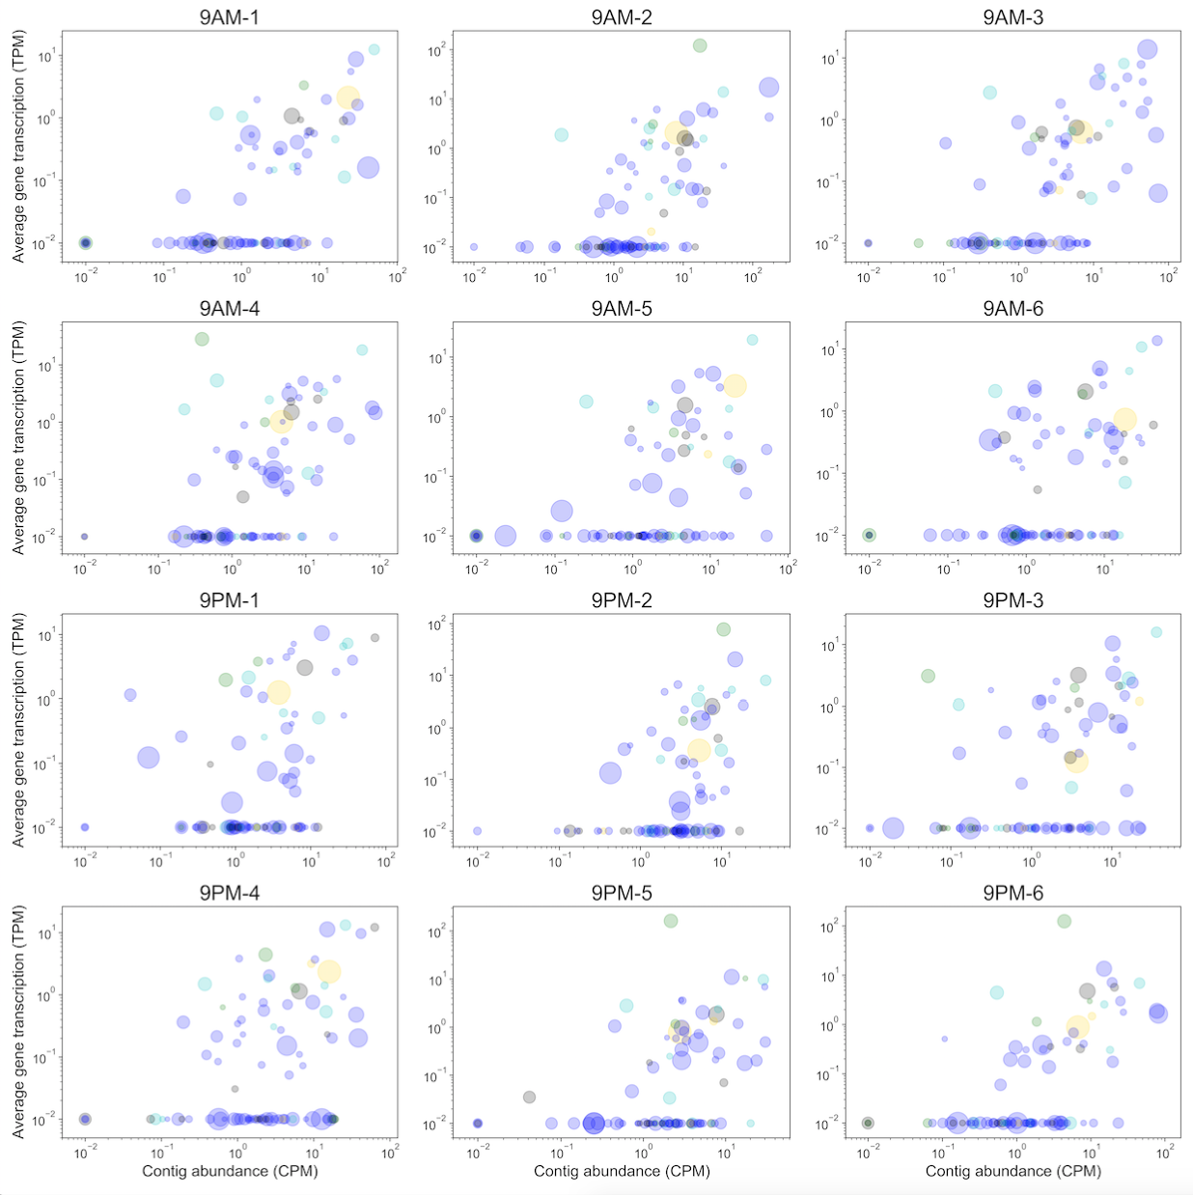

*Fig S3: Viral contig total transcriptional activity (TPM) and abundance (CPM) across the 12 replicates. Size of points represents the relative length of viral contig and color denotes the taxonomy of predicted host (blue: Euryarchaeota, cyan: Proteobacteria, green: Cyanobacteria, gold: Bacteroidetes, gray: unkonwn).*



*Fig. S4: Distribution of Pearson correlation between total transcriptional activity (TPM) and total abundance (CPM) of viral contigs across the 12 replicates.*

**

*Fig. S5: Gene similarity network of RefSeq viruses (black) together with viral contigs identified in this study (blue). Genus-level taxonomy was determined using VContact2 with all prokaryotic viruses with ICTV + NCBI Taxonomy and DIAMOND method of protein sequence comparison. Any genomes that were found to be singletons, i.e. those that lack a sufficient number of shared genes to belong to a mutli-genome genus, were not displayed.*

 

*Fig S6: (A) An unrooted phylogenetic tree of a random subset of 500 Chlorophyta (green algae) species from the SILVA database, including all available sequences from the Mamiellophyceae class (highlighted in blue), constructed from a multiple alignment of 18S rRNA sequences. (B) Zoomed-in view of the Mamiellophyceae class phylogeny, showing clustering of the 18S rRNA sequence from the halite algae together with members of the Dolichomastix genus (highlighted in blue; the closest sequence a Lake Tyrrel isolate under GenBank accession number KC486366.1).*

*Fig. S7: (A) The distribution of isoelectric points (pI) of predicted genes in various algal genomes, including the novel Dolichomastix. (B) The predicted pIs of homologous proteins identified in both Dolichomastix spp. and M. pusila genomes, showing biases in pI preferences between the two genomes. (C) The GC content and average expression of Dolichomastix alga genes, with genes that are homologous to proteins found to be important in high-salt tolerance of the D. salina alga highlighted in black. (D) The distribution of isoelectric points (pI) of the Dolichomastix spp. chromosomes, mitochondria, and chloroplast.*



*Fig. S8: Relative prevalence of major KEGG functional pathways in the metagenomic (red) and metatranscriptomic (blue) samples. The pathway abundance (DNA) and expression (RNA) value were the combined total CPM or TPM (respectively) of the genes that constitute that pathway. All samples were standardized to an equal total coverage of all pathways, and then scaled to the maximum value for each row (pathway).*



*Fig. S9: The mean transcriptional activity ratio of major highly-expressed KEGG pathways in the major taxa found in the halite communities. The relative activity is the ratio of total pathway expression (TPM) to the pathway’s abundance (CPM) in each taxa.*

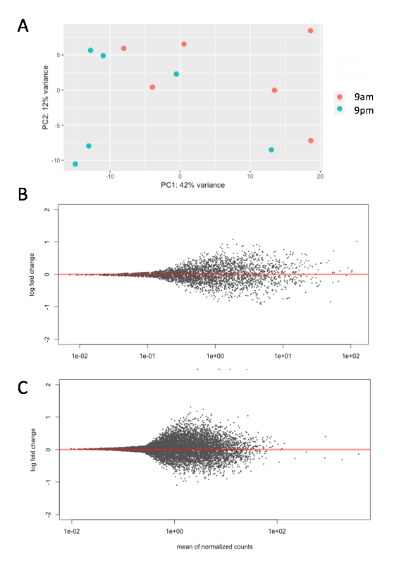

*Fig S10. DESeq differential expression analysis of the halite community between 9am and 9pm time points. (A) Clustering between the time points shown with a PCA of the expression profile of the entire community. (B) Lack of significantly differentially expressed genes (q-value<0.01) in the Halothece Cyanobacteria and (C) Dolichomastix alga MAGs. Gene expression was expressed as transcripts per million (TPM), further standardized to the total transcription of the contig (A) or MAG (B,C) that they belong on to account for inter-replicate variation in abundance and activity.*



*Fig. S11: Variance in pathway abundance in metagenome replicates (cyan) and variance in pathway expression in metatranscriptome replicates (gold) shown for major phylogenetic groups of the halite community.*